**Lecture 9**

**POWER SERIES IN *x***

The series of the form

 (1)

is called a ***power series in x***.

where are constants and *x* is a variable.

**RADIUS AND INTERVAL OF CONVERGENCE**

If a numerical value is substituted for *x* in a power series (1), then the resulting series of numbers may either converge or diverge. This leads to the problem of determining the set of *x*-values for which a given power series converges; this is called its ***convergence set***.

Observe that every power series in *x* converges at *x* = 0, since substituting this value in (1) produces the series

*a*0 + 0 + 0 + 0+・ ・ ・+0+・ ・ ・

whose sum is *a*0. In some cases *x* = 0 may be the only number in the convergence set; in other cases the convergence set is some finite or infinite interval containing *x* = 0. This is the content of the following theorem, whose proof will be omitted.

**Theorem.** *For any power series in x, exactly one of the following is true:*

(*a*) *The series converges only for x* = 0*.*

(*b*) *The series converges absolutely (and hence converges) for all real values of x.*

(*c*) *The series converges absolutely (and hence converges) for all x in some finite*

*open interval (*−*R,R) and diverges if x <* −*R or x > R. At either of the values*

*x* = *R or x* = −*R, the series may converge absolutely, converge conditionally, or*

*diverge, depending on the particular series.*

The usual procedure for finding the interval of convergence of a power series is to apply the ratio test for absolute convergence

. (7)

**1-мысал**.  қатардың жинақтылық интервалын анықтап, интервал ұштарында жинақтылыққа зерттеу керек.

Шешуі. Қатардың жинақталу радиусын (7) шекті қолданып табайық. Мұнда, . Шек есептейік:

.

Демек, қатардың жинақталу интервалы .

Енді интервал ұштарында, яғни  болғандағы сандық қатарларды жинақтылыққа зерттейік.

 болғанда дәрежелік қатардан  гармоникалық қатар аламыз. Ал ол жинақталмайтын қатар екендігі белгілі. Олай болса,  жинақтылық облысына кірмейді.

 болғанда дәрежелік қатардан  таңбасы ауыспалы қатар аламыз. Лейбниц белгісі бойынша бұл қатар жинақталатын қатар. Олай болса,  жинақтылық облысына кіреді.

Сонымен, берілген дәрежелік қатардың жинақталу облысы  болады екен.

**2-мысал**.  қатардың жинақталу облысын анықтау керек.

Шешуі. Қатардың жалпы мүшесінің коэффициенті және Шек есептейік



.

Демек, қатар тек бір нүктеде,  нүктесінде ғана жинақталады екен.

**3-мысал**.  қатардың жинақталу облысын анықтау керек.

Шешуі. Қатардың жалпы мүшесінің коэффициенті . Шек есептейік:



Демек, қатар  интервалда, яғни бүкіл сан осінде жинақталады.

1. **Theorem.** *If a function f can be represented by a power series in x* − *x*0

*with a nonzero radius of convergence R, then f has derivatives of all orders on the*

*interval (x*0 − *R, x*0 + *R).*



2. *If α and β are points in the interval (x*0 − *R, x*0 + *R), and if the power series representation of f is integrated term by term from α to β, then the resulting series*

*converges absolutely on the interval (x*0 − *R, x*0 + *R) and*



.

**MACLAURIN AND TAYLOR POLYNOMIALS**

In a local linear approximation the tangent line to the graph of a function is used to

obtain a linear approximation of the function near the point of tangency. In this section we will consider how one might improve on the accuracy of local linear approximations by using higher-order polynomials as approximating functions. We will also investigate the error associated with such approximations.

LOCAL QUADRATIC APPROXIMATIONS

Recall from Formula (1) that the local linear approximation of a function *f* at *x*0 is

*f(x)* ≈ *f(x*0*)* + *(x-x0)* (1)

In this formula, the approximating function

*p(x)* = *f(x*0*)* + *(x-x0)*

is a first-degree polynomial satisfying *p(x*0*)* = *f(x*0*)* and ** (verify).

Thus, the local linear approximation of *f* at *x*0 has the property that its value and the value of its first derivative match those of *f* at *x*0. If the graph of a function *f* has a pronounced “bend” at *x*0, then we can expect that the accuracy of the local linear approximation of *f* at *x*0 will decrease rapidly as we progress away from *x*0 (Figure 2).

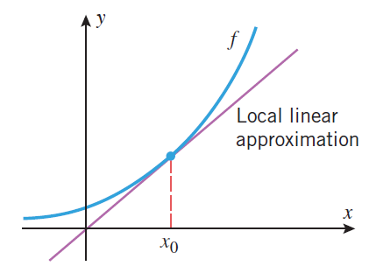

Figure 2.

One way to deal with this problem is to approximate the function *f* at *x*0 by a polynomial *p* of degree 2 with the property that the value of *p* and the values of its first two derivatives match those of *f* at *x*0. This ensures that the graphs of *f* and *p* not only have the same tangent line at *x*0, but they also bend in the same direction at *x*0 (both concave up or concave down). As a result, we can expect that the graph of *p* will remain close to the graph of *f* over a larger interval around *x*0 than the graph of the local linear approximation. The polynomial *p* is called the ***local quadratic approximation of f at x* = *x*0**.

To illustrate this idea, let us try to find a formula for the local quadratic approximation of a function *f* at *x* = 0. This approximation has the form

*f(x)* ≈ *c*0 + *c*1*x* + *c*2*x*2 (2)

where *c*0, *c*1, and *c*2 must be chosen so that the values of

p(x) = c0 + c1x + c2x2

and its first two derivatives match those of *f* at 0. Thus, we want

*p(*0*)* = *f(*0*), p'(*0*)* = *f'(*0*), p''(*0*)* = *f''(*0*)* (3)

But the values of *p(*0*)*, *p'(*0*)*, and *p''(*0*)* are as follows:

p(x) = c0 + c1x + c2x2 p(0) = c0

*p'(x)* = *c*1+ 2*c*2*x* *p'(*0*)* = *c*1

*p'' (x)* = 2*c*2 *p''(*0*)* = 2*c*2

Thus, it follows from (3) that

*c*0 = *f(*0*), c*1 = *f '(*0*), c*2 = *f ''(*0*)/2*

and substituting these in (2) yields the following formula for the local quadratic approximation of *f* at *x* = 0:

*f(x)* ≈ *f(*0*)* + *f '(*0*)x* + **  (4)

**Example 1.** Find the local linear and quadratic approximations of *ex* at *x* = 0, and

graph ex and the two approximations together.

***Solution.*** If we let *f(x)* = *ex* , then *f '(x)* = *f''(x)* = *ex*; and hence

*f(*0*)* = *f’(*0*)* = *f'' (*0*)* = *e*0 = 1

Thus, from (4) the local quadratic approximation of *ex* at *x* = 0 is

*ex* ≈ 1 + *x* + *x*2/2

and the local linear approximation (which is the linear part of the local quadratic approximation) is

ex ≈ 1 + x

The graphs of *ex* and the two approximations are shown in Figure 2. As expected, the local quadratic approximation is more accurate than the local linear approximation near

x = 0.

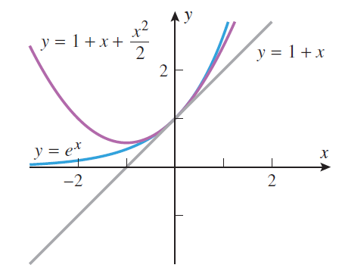

Figure 2.